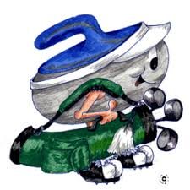
Brighton and District Curling Club 9th Annual
SWEEP AND SWING EVENT

Saturday, October 14, 2023
Enjoy a great day of Curling, Golf and Socializing
Your entry fee includes 4 ends of curling, a delicious lunch, 9 holes of golf at Barcovan Golf Course (cart extra) and prizes.
Entry Fee - $90.00 per person
No curling or golf experience is required.
You may enter a single, a couple or create a team of four.
Register with Joanne and Larry Arbour at jlarbour28@gmail.com or 613-813-5323
First 32 paid entries guaranteed so be sure to sign up early!!
Payment can be done via etransfer to jlarbour28@gmail.com

