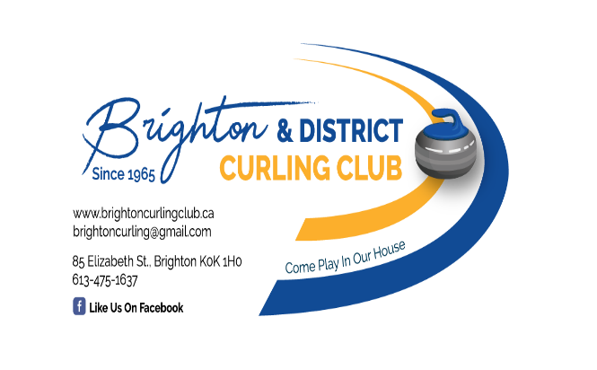

October 6, 2022

COVID-19 Policies and Protocols

These policies and protocols are developed and updated by the Board of Directors in line with the most recent public health protocols. Check back often to make sure you are aware of the most recent updates.

If you have COVID-19 symptoms, presume you have the virus and stay home. If you are ill or have received a confirmation through testing, you MUST isolate at home to protect others and prevent the spread of COVID-19. Do not attend work, school, child care or other public places. Here is the link to our public health unit:

Positive for COVID-19 – What should you do? – Haliburton, Kawartha, Pine Ridge District Health Unit (hkpr.on.ca)

If you have a positive COVID test, please advise curlers you were in close contact with in the two days prior to your test. Use the Members’ Home – League Information – Teams – email the team(s).

WHO IS A CLOSE CONTACT? (ottawapublichealth.ca)

Persons participating in indoor activities will be restricted to current provincial capacity limits.

Wearing a mask is encouraged except when on the ice or seated and drinking or eating. Whenever possible, members are asked to keep 2M apart from others.

The club will provide adequate hand sanitizer and wipes at locations throughout the club, including entry, lounge, locker rooms, washrooms, and each end of each ice surface. Members are encouraged to bring their own masks, tissues, water, brooms or delivery sticks, helmets, grippers and sliders. Users of club equipment (brooms, stabilizers, sticks) must sanitize them after each use.

Washrooms will be sanitized each day.

Registration

Members will register to curl on-line only. If members do not have access to internet or are unable to complete registration, they will contact the Membership Coordinator by phone and provide the required information.

Members will be encouraged to pay fees by 'e transfer' to reduce the number of cheques and cash to be processed. Other arrangements will be provided for members who are unable to use 'e-transfer' service.

Pro-rated fee refunds will be provided should the pandemic situation seriously degrade during the season to the point of having to close the club.

At the rink

Any member who is not well or who has family members not well is asked not to participate.

Players can access the change rooms but must keep strict 2M separation. Lockers are available on a first come, first serve basis. Masks must be worn at all times in the locker room.

Scores for each team are to be transmitted by the winning skip to the league convenor electronically.

On Ice Protocols

Physical Distancing (6 ft/2M – a broom’s length!) According to our Public Health Unit, this is the most important rule to follow.
- All skips and vice-skips when in house must stay 6 feet/2M apart.

- Do not congregate at the back boards when coming on and leaving the ice. Enter and leave with 6 feet/2M between you and the next person.

- No physical contact before, during or after the game. No fist-pumps or high-fives.

- At the completion of the end, only one player from each team should move their team rocks to the back boards.

- Just because you are wearing a mask does not mean you can be closer than 6 feet/2M.

- There will be no handshakes or other form of contact prior to, during, or on completion of the game.

- Teams determine who has hammer before proceeding to the ice. Leads sanitize the handles of the rocks for their team and then proceed to their designated positions.

- Seconds and Vice-Skips go immediately down ice.

- Skips will immediately proceed directly to the target end.

- Each player is responsible for selecting their own rock for play and will not touch other rocks. If other rocks need to be moved, they will be moved using a broom.

Sweeping
- Two sweepers are allowed.
- One sweeper may sweep behind the tee line and may sweep opposition rocks.
- Please respect any curler who chooses not to sweep in close proximity to others.

Masks
- Wearing a mask is encouraged off ice at all times unless you are seated and using the kitchen/bar services. This includes while entering and leaving the ice.
- Masks are optional on the ice but strongly encouraged. If you can wear a mask, please do so. Our Public Health Unit advises that masks are an extra precaution and do not replace physical distancing.
- Masks are intended to keep the wearer’s droplets (coughs, sneezes, heavy breathing) to themselves. They should cover the nose, mouth and chin to be effective. It is all about containing droplets.
- Just because you are wearing a mask does not mean you can be closer than 6 ft/2M.

October 6, 2022

