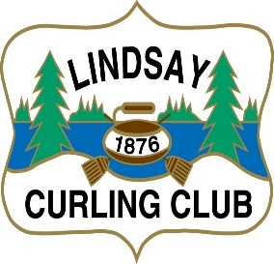
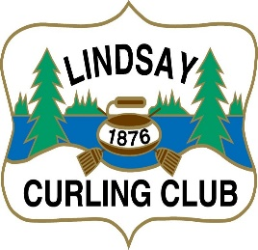
2-Person Stick Bonspiel
Saturday February 7, 2026
Celebrating 150 Years
24 Teams – Men, Women or Mixed 3 games per team
Lunch Included Entry Fee - $100 per team
Drawtimes–9:00 am or 10:30 am Cash Prizes for each draw
Deadline for entry-February1, 2026
Entry Form & Payment Options
Option #1 Cheque-Submit Entry Form & Payment
Payable to- Lindsay Curling Club 2-Person Stick Spiel
Attention: Dave Nigh
18 Peel Street, Lindsay, Ontario, K9V3L8

Option #2 E-Transfer-Submit Entry Form & e-transfer to lindsaycurlingclub@cogeco.net
In message box, please include Lindsay 2-person Stick Bonspiel
Your Full Name and Your Home Club

Team Entry Fee-$100.00

Team Members: _________________________________________________

Preferred Draw (please circle one): 9:00 am or 10:30 am

Affiliated Curling Club: ________________________________

Contact Information:

Name: _________________________________

E-mail: __________________________________________________

Phone #: ____________________________

